CHAPTER 11: MULTITHREADING IN PYTHON
TOPICS COVERED:
11.1 WHAT IS A THREAD
11.2 DEFINITION OF MULTITHREADING
11.3 BENEFITS OF USING MULTITHREADING
11.4 TYPES OF MODULES in threading
11.5 FUNCTIONS OF THREADING MODULE
11.6 SAMPLE CODING OF MULTITHREADING

11.1 WHAT IS A THREAD (CONCURRENT EXECUTION – CONCURRENCY CONTROL)
- Thread is usually a tiny part of execution with independent set of instructions within it.
- Thread is a part of process which can be scheduled for execution.
- Thread operates in the same runnable resources of process.
- Thread shares memory with other threads.
- Thread uses context switching technique inside process.
- Thread uses signal masking.
- Thread has an instruction pointer which contains current state of a thread.
- Thread has a program counter and register set.
- Thread has identifier which returns the exact memory location of a thread.
- Components ( instruction pointer, TRS, TPC, P2cP,TSP,TID,PID) – monitored by TCB

11.2 DEFINITION OF MULTITHREADING
- Multithreading means ability of a process to execute more than one thread concurrently at a time.
- Multithreading significantly improves the performance of any python program.
- Multithreading is user friendly.
- Multithreading involves concurrency execution of stored threads in a program.
11.3 BENEFITS OF USING MULTITHREADING
- Multithreading Improves speed of computation process (automation)
- Multithreading makes a program to be more responsible even it waits for getting input resources
- Multithreading of a process have complete access to use global variables
- Changes made in one thread will automatically visible to remaining threads
- Threads may also have its own local variables
11.4 TYPES OF MODULES
- Python offers two different modules for enable multithreading. There are,
  - <_thread> module [to achieve backward compatibility from python 2 series thread module]
  - <threading> module
- Each module in python has its own execution methods.
- <_thread > module takes a thread as a function
- <threading> module takes a thread and applies object oriented approach to thread creation.
- Execution method of <_thread> module is start_new_thread()
- Execution method of <threading> module is thread.start () and it uses join() method to save the previous thread execution information for a while.
11.5 FUNCTIONS OF THREADING MODULE
- Threading module has its own set of predefined built in functions which are used to state some useful information and behavior of current and main thread. There are,
- Threading.active_count () - Threading.get_ident ()
- Threading.main_thread () - Threading.current_thread ()
- Threading.enumerate ()

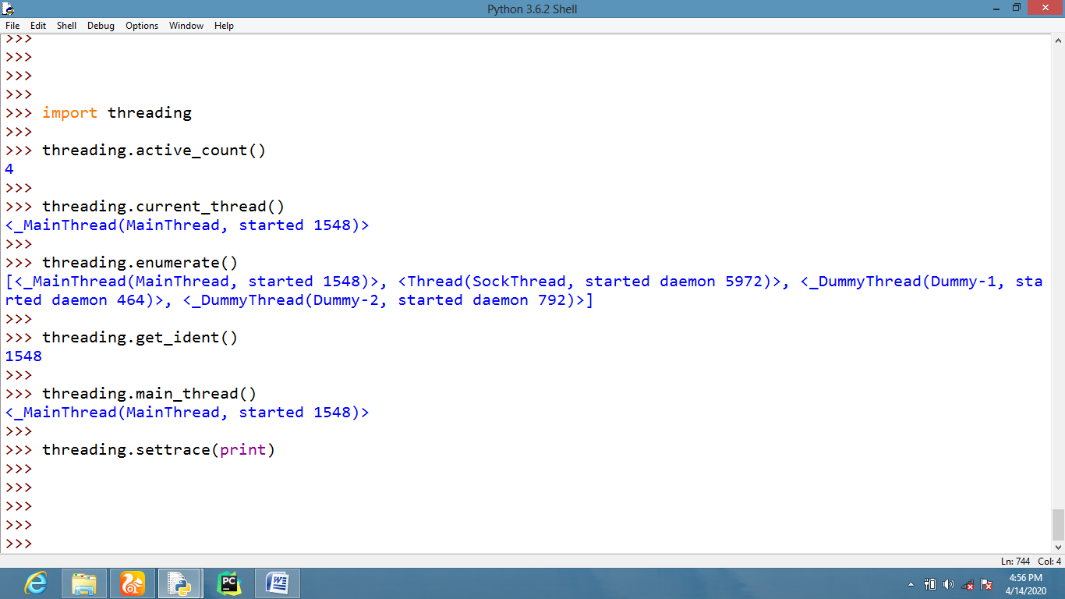
11.6 SAMPLE CODING OF MULTITHREADING
